* **UML Class Diagram (Updated):**

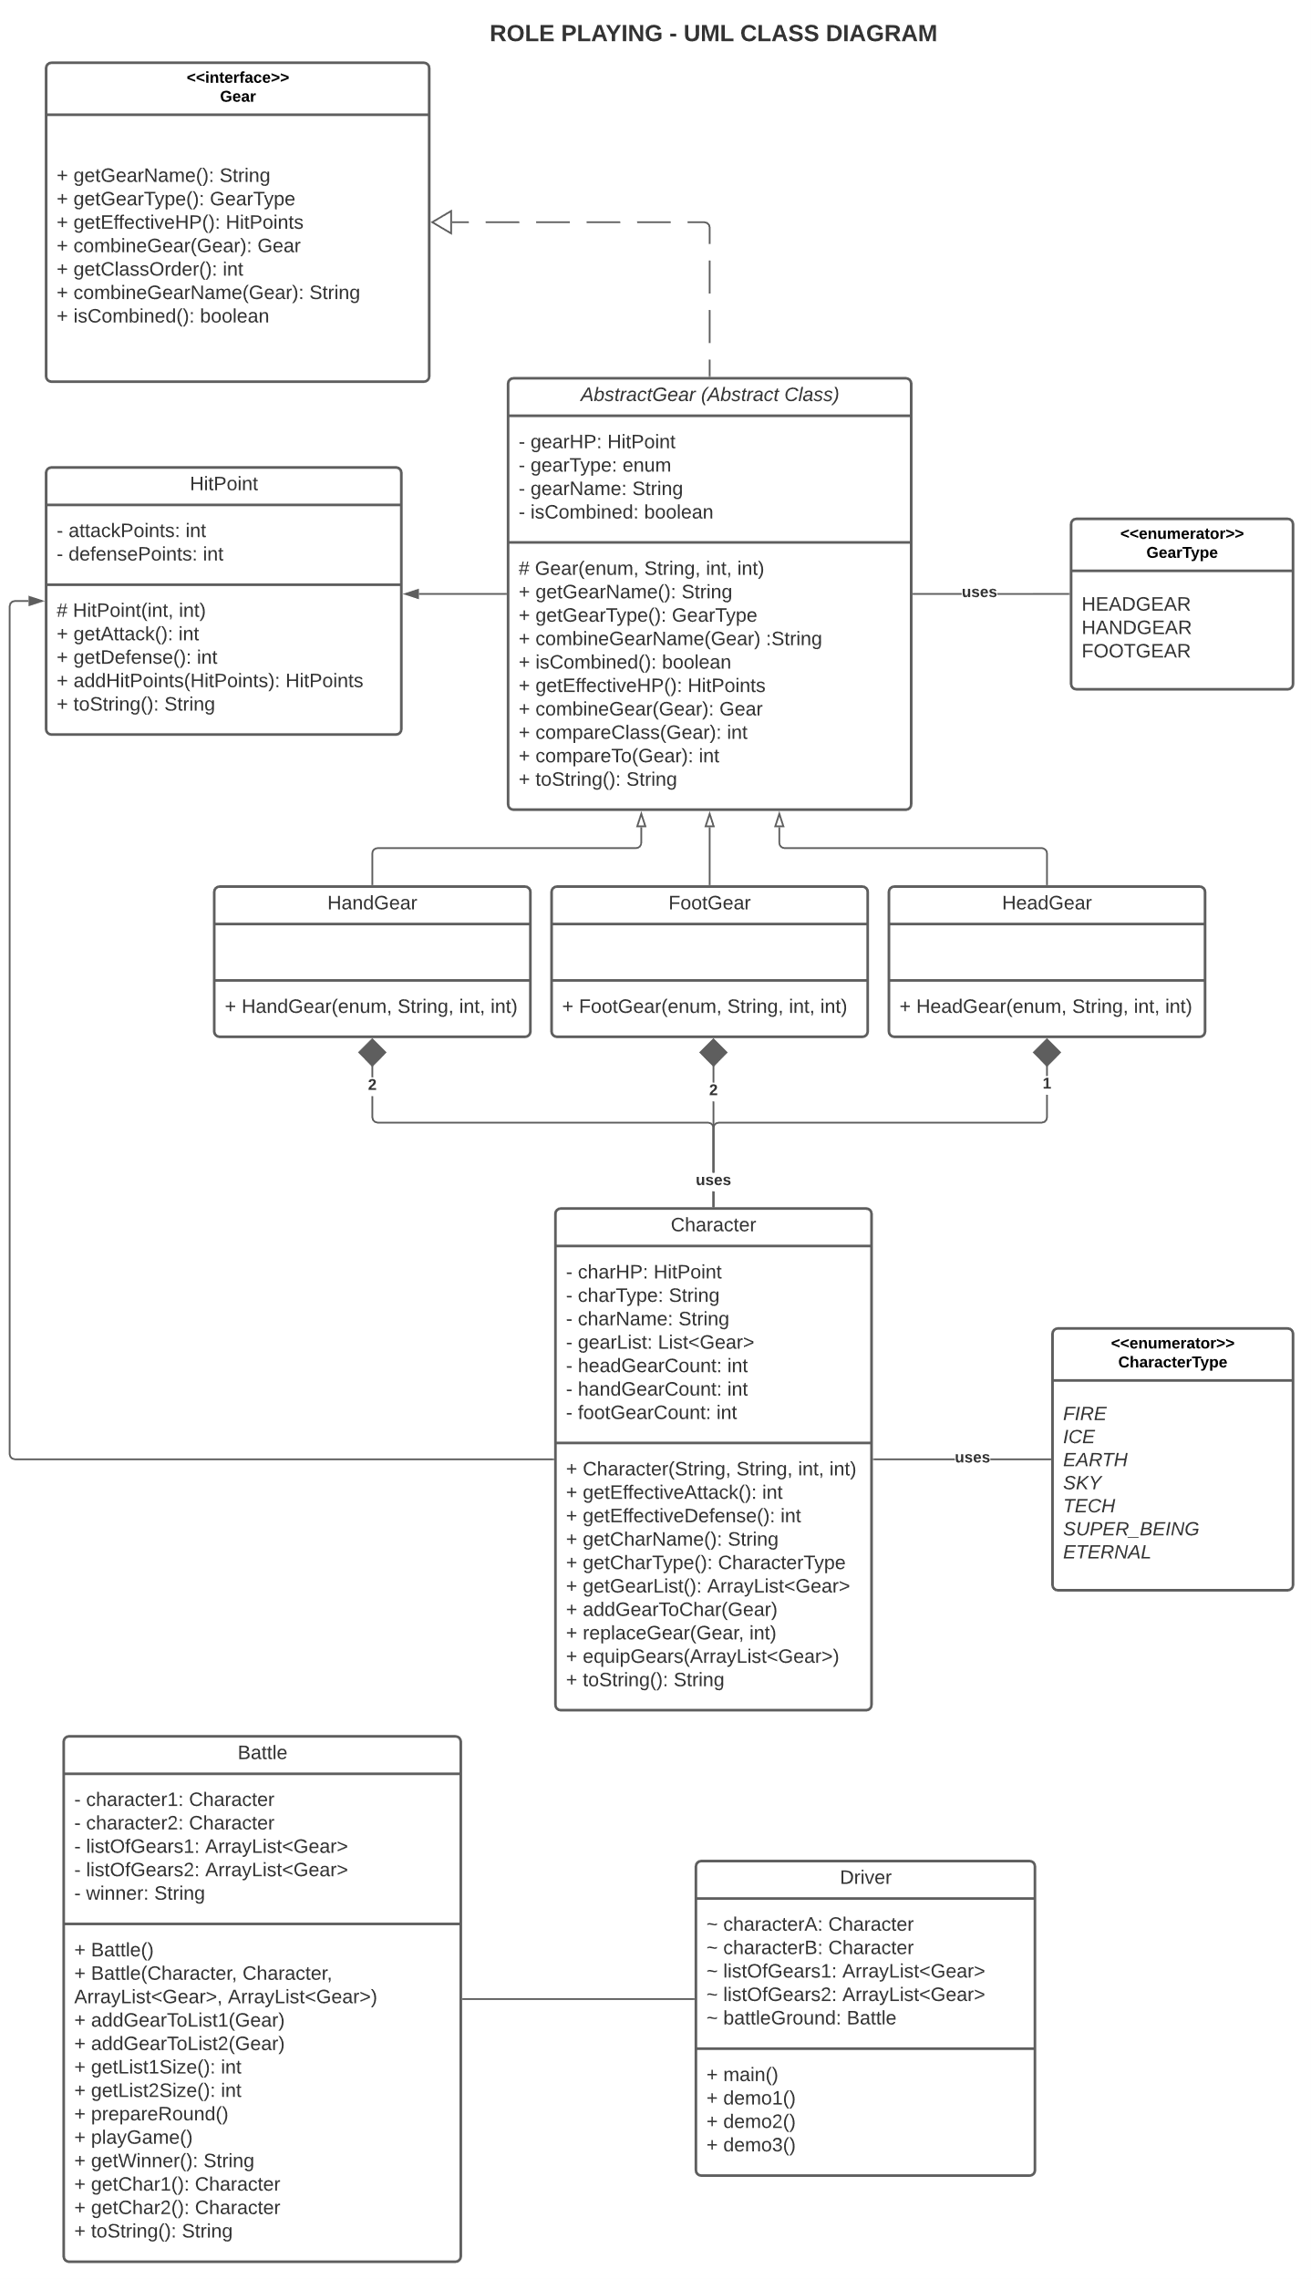

* **Design Explanation:**
  + **Package Name:** roleplaying
  + **Character Class:**
    - The character class consists of fields (Like Name of the character, type of character, attack points and defense points) that describe a character of the game.
    - The character uses HitPoint object to define its attack and defense points.
    - The character has the capacity to pick/choose gears from a list of 10 gears available that can be equipped to increase the hitpoint stats of the character. This can be done using the **equipGears(ArrayList<Gear>)** method of this class. The constraints are it can’t pick more than 2 hand gears, 2 foot gears and 1 head gear. This method further user helper methods **addGearToChar(Gear)** and **replaceGears(Gear, int)** used to add the gear to the character after passing through all the checks and constraints and replace the existing gears with that of combined gears respectively.
    - It has the ability to combine 2 gears of same type. The method **combineGear(Gear)** of the gear object is used to perform the same.
    - **getEffectiveAttack() and getEffectiveDefense()** methods will give the user the increased attack points and increased defense points respectively after the character has equipped the gears.
    - The **getter methods** are used to view what values are set for the fields of a character.
    - The **toString()** method is overwritten to display the stats and summary of a character object.
    - The chacter class has ‘***has-a***’ relationship with the gear class via the gear interface.
  + **Gear Interface:**
    - The gear interface consists of all the methods that needs to be implemented by the gear class.
    - The gear class is defined as abstract to offer encapsulation and enable DRY (Don’t Repeat Yourself) for code refactoring.
    - The gear class uses HitPoint object to define the attack and defense points of the gears.
    - The gear class has children (sub-class) belonging to each class of gears namely: Head Gear. Hand Gear, Foot Gear.
    - The children class inherits all the fields and methods of the parent class.
    - The **getEffectiveHP()** method is used to get the HP of the gear (applicable to both raw gear and combined super gears).
    - **combineGear(Gear)** is used to combine to gears of same type. Throws an exception if 2 different types of gear are provided. If valid, creates a new combined gear with new name and HP.
    - **combineGearName(Gear)** is used to generate new name for the combined gear.
    - **isCombined()** is used to check if a gear is a combined gear or not.
    - **getClassOrder()** is used to get the order of precedence of the classes when sorting the gears.
  + **Battle Class:**
    - The battle class constructor instantiates the objects of characters, gears and hitpoints.
    - The battle class has another constructor as an option to provide the objects if the game as arguments passed externally.
    - **addGearToList1(Gear)** and **addGearToList2(Gear)** are methods used to add gears one by one to the list of gears that are available for the characters to choose from.
    - **prepareRound()** is used to prepare the players for battle. That is this is where the players choose gears to upgrade themselves.
    - **playGame()** is where the game between the 2 upgraded characters is played. Here based on their hit points a player is given the title of winner. The outcome of the duel is displayed here.
    - **getWinner()** outputs the winner of the battle.
  + **Driver Class:**
    - The driver class is where the main function resides.
    - The main function is where a quick game demo is played. That is, objects of class gears and characters are instantiated and are used to play the game.
    - The main function uses 3 demo methods. The documentation in the functions are self explanatory. These three demo serves as a demo for 3 different ways in which the game can be played/interacted by the user.
    - The demo methods has local objects of the battle class and are interacting through that class/object only to play the game and get the winner of the game.
* **Testing Plan:**

**The classes to be tested are tested in separate test classes, to enable modularity in testing and also to cover all the functionalities of the respective classes (BattleTest, CharacterTest, GearTest, HitPointTest).**

* + **Test 1:** To check if an object of class character is created properly.
  + **Test 2:** To check if an object of class HandGear is created properly.
  + **Test 3:** To check if an object of class HeadGear is created properly.
  + **Test 4:** To check if an object of class FootGear is created properly.
  + **Test 5:** To check if an object of class HitPoints is created properly.
  + **Test 6:** To check if an object of class HitPoints can be added to another object of the same class.
  + **Test 7:** To check if an exception is thrown if an object of class HitPoints is added to object of type Integer or some other data type.
  + **Test 8:** To check if 2 gears of same type are combined properly.
  + **Test 9:** To check if an exception is thrown if 2 gears of different types are combined.
  + **Test 10:** To check if an exception is thrown if the character tries to pick more than 2 hand gears at a time.
  + **Test 11:** To check if an exception is thrown if the character tries to pick more than 2 foot gears at a time.
  + **Test 12:** To check if an exception is thrown if the character tries to pick more than 1 head gear at a time.
  + **Test 13:** To check if a character’s hit-points have changed accordingly after the character has been equipped with some gears.
  + **Test 14:** To check if toString method of the Character class is providing the expected output.
  + **Test 15:** To check if player 1 has won.
  + **Test 16:** To check if player 2 has won.
  + **Test 17:** To check if the game has been tied.
  + **Test 18:** To check if the functionality of custom sorting of gears are working correctly.
  + **Test 19:** To check if the battle class is working correctly.
  + **Test 20 – 35:** To check for individual public methods of the classes Battle, Gear, Hitpoint, Character including a wider coverage of testing.
* **Assumptions Made:**
  + Each character gets a separate arsenal of gears to choose from.
  + Game can be played even without wearing any gears.
  + Sorting of the given list of gears to enable ease of selection of gears for the characters.
* **Challenges Faced:**
  + Various assumptions that makes the above choices dependent of them.
    - Whether same items will be available for the second character who picks the items at last.
    - Whether a character can take up to 8 items {3 hand gears (1 combo, 1 raw), 3 foot gears (1 combo, 1 raw), 2 head gears (1 combo)}.
  + Use of relationships between classes were a challenge. That is, whether to use “Association” or “Composition” relationship between the character and the gear.
  + To define the access modifiers(visibility) of the class methods.